**Chapter 7: Multiple Access**

1. **Introduction**

When nodes or stations are connected and use a common link, called a multipoint orbroadcast link, we need a multiple-access protocol to coordinate access to the link.The problem of controlling the access to the medium is similar to the rules of speaking inan assembly. The procedures guarantee that the right to speak is upheld and ensure thattwo people do not speak at the same time, do not interrupt each other, do not monopolizethe discussion, and so on. Many protocols have been devised to handle access to a sharedlink. All of these protocols belong to a sublayer in the data-link layer called media accesscontrol (MAC).

1. **Random Access**

In random-access or contention methods, no station is superior to another station andnone is assigned control over another. At each instance, a station that has data to senduses a procedure defined by the protocol to make a decision on whether or not to send.This decision depends on the state of the medium (idle or busy).Two features give this method its name. First, there is no scheduled time for astation to transmit. Transmission is random among the stations. That is why thesemethods are called random access. Second, no rules specify which station should sendnext. Stations compete with one another to access the medium.

In a random-access method, each station has the right to the medium without beingcontrolled by any other station. However, if more than one station tries to send, there isan access conflict and the frames will be either destroyed or modified. Random access methods can be categorized as follows:-

1. ALOHA
2. CSMA
3. CSMA/CD
4. CSMA/CA
   1. **Pure ALOHA**

The original ALOHA protocol is called pure ALOHA. This is a simple but elegant protocol.The idea is that each station sends a frame whenever it has a frame to send (multipleaccess). However, since there is only one channel to share, there is the possibilityof collision between frames from different stations. Figure 1 shows an example offrame collisions in pure ALOHA.

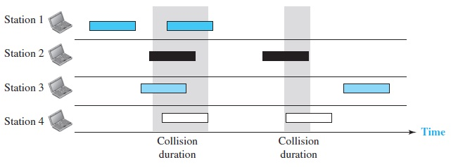

Figure 1. Frames in a pure ALOHA network

There are four stations that contend with one another for access to the shared channel. The figure shows that each station sends two frames; there are a total of eight frames on the shared medium. Some of these frames collide because multiple frames are in contention for the shared channel. Figure 1 shows that only two frames survive: frame 1.1 from station 1 and frame 3.2 from station 3. We need to mention that even if one bit of a frame coexists on the channel with one bit from

another frame, there is a collision and both will be destroyed. The pure ALOHA protocol relies on acknowledgments from the receiver. When a station sends a frame, it expects the receiver to send an acknowledgment. If the acknowledgment does not arrive after a time-out period, the station assumes that the frame (or the acknowledgment) has been destroyed and resends the frame.

**Vulnerable time of Pure ALOHA**

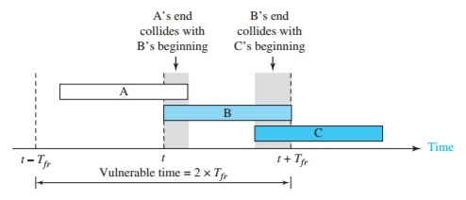

Figure 2. Vulnerable time of pure ALOHA

* 1. **Slotted ALOHA**

In slotted ALOHA we divide the time into slots of Tfr seconds and force the station to send only at the beginning of the time slot.

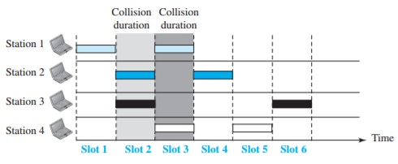

Figure 3. Frames in a slotted ALOHA network

Because a station is allowed to send only at the beginning of the synchronized time slot, if a station misses this moment, it must wait until the beginning of the next time slot. Of course, there is still the possibility of collision if two stations try to send at the beginning of the same time slot. However, the vulnerable time is now reduced to one-half, equal to Tfr.

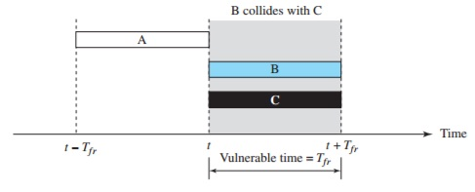

Figure 4. Vulnerable time of slotted ALOHA

* 1. **CSMA**

To minimize the chance of collision and, therefore, increase the performance, the Carrier sense multiple access (CSMA) method was developed. The chance of collision can be reduced if a station senses the medium before trying to use it. CSMA requires that each station first listen to the medium before sending.

The possibility of collision still exists because of propagation delay; when a station sends a frame, it still takes time (although very short) for the first bit to reach every station and for every station to sense it.

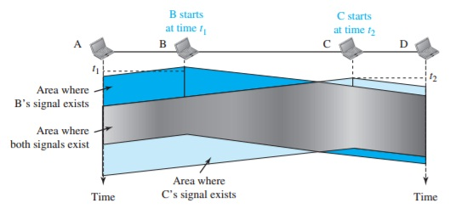

Figure 5. Space/time model of a collision in CSMA

At time t1, station B senses the medium and finds it idle, so it sends a frame. At time t2 (t2 > t1), station C senses the medium and finds it idle because, at this time, the first bits from station B have not reached station C. Station C also sends a frame. The two signals collide and both frames are destroyed.

**Vulnerable time for CSMA**

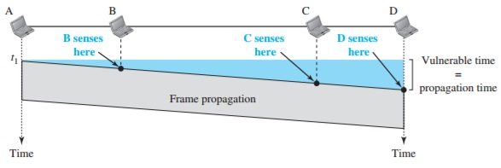

Figure 6. Vulnerable time for CSMA

* 1. **CSMA/CD**

The CSMA method does not specify the procedure following a collision. Carrier sense multiple access with collision detection (CSMA/CD) augments the algorithm to handle the collision. In this method, a station monitors the medium after it sends a frame to see if the transmission was successful. If so, the station is finished. If, however, there is a collision, the frame is sent again.

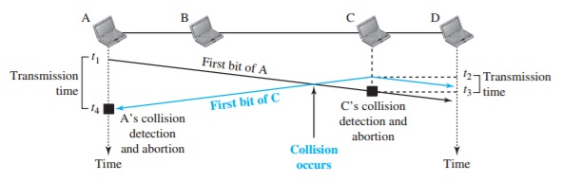

Figure 7. Collision for the first bits in CSMA/CD

At time t1, station A has executed its persistence procedure and starts sending the bits of its frame. At time t2, station C has not yet sensed the first bit sent by A. Station C executes its persistence procedure and starts sending the bits in its frame, which propagate both to the left and to the right. The collision occurs sometime after time t2. Station C detects a collision at time t3 when it receives the first bit of A’s frame. Station C immediately (or after a short time, but we assume immediately) aborts transmission. Station A detects collision at time t4 when it receives the first bit of C’s frame; it also immediately aborts transmission. Looking at the figure, we see that A transmits for the duration t4 − t1; C transmits for the duration t3 − t2.

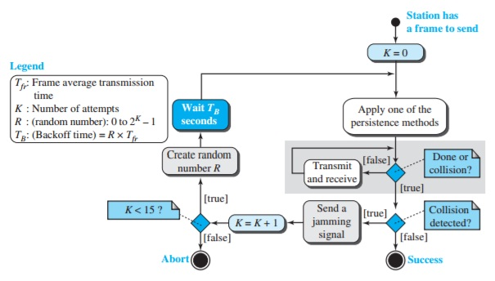

Figure 8. Flow diagram for CSMA/CD

* 1. **CSMA/CA**

Carrier sense multiple access with collision avoidance (CSMA/CA) was invented for wireless networks. Collisions are avoided through the use of CSMA/CA’s three strategies: the interframe space, the contention window, and acknowledgments.

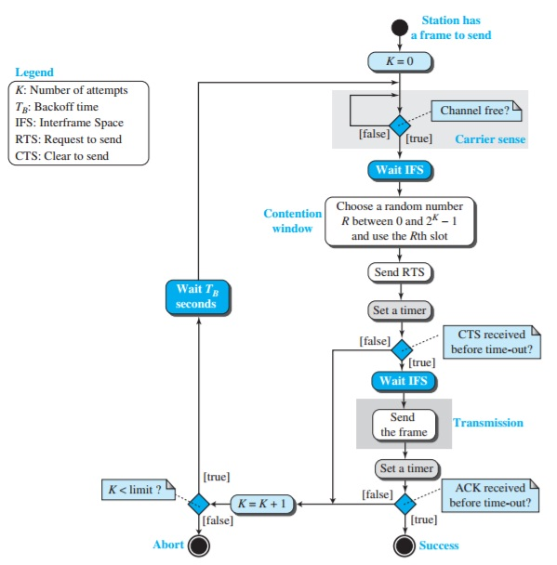

Figure 9. Flow diagram of CSMA/CA